课程名称 算法分析与设计 学号 1807004242 学生姓名 刘宾宾 教师 井超
专业 | 数据科学与大数据技术 | 实验室名称 |  | 实验时间
实验名称
变治法应用二：AVL树的插入与删除
实验目的
利用变治法来实现AVL树的创建与删除，了解创建的过程，并且保证AVL树的平衡性，增加对变治法的了解。
实验题目
AVL树的插入与删除。
实验源代码
def getblance(node):
if node:
return node.blance
else:
return -1
def right_rotate(node):
# 三步完成右旋转操作
node_left = node.left
node.left = node_left.right
node_left.right = node
# 更新节点的高度
node_left.blance = max(getblance(node_left.left),
getblance(node_left.right)) + 1
node.blance = max(getblance(node.left), getblance(node.right)) + 1
return node_left
def left_rotate(node):
# 三步完成左旋转操作
node_right = node.right
node.right = node_right.left
node_right.left = node
# 更新节点的高度
node.blance = max(getblance(node.left), getblance(node.right)) + 1
node_right.blance = max(getblance(node_right.left), getblance(node_right.right)) + 1
return node_right
def left_right_rotate(node):
node.left = left_rotate(node.left) # 左旋
return right_rotate(node) # 右旋
def right_left_rotate(node):
node.right = right_rotate(node.right) # 右旋
return left_rotate(node) # 左旋
def printtree(node):
if node:
print("", node.key, " ", node.blance)
printtree(node.left)
printtree(node.right)
class treeNode(object):
def __init__(self, key):
# height为当前节点的高度
self.key = key
self.left = None
self.right = None
self.blance = 0
class AVLtree(object):
def __init__(self):
self.root = None
def insert(self, node):
# 把第一个插入的节点设置为根节点
if self.root is None:
self.root = node
else:
self.root = self._insert(self.root, node)
def _insert(self, index, node):
# index: 根节点;node: 要插入的节点;递归实现插入
if index is None:
index = node
elif node.key < index.key:
index.left = self._insert(index.left, node)
if getblance(index.left)-getblance(index.right) == 2:
if node.key < index.left.key:
index = right_rotate(index) # 如果插在最左边，则右旋
else: # 如果插在左子节点的右子树上，则先左旋后右旋
index = left_right_rotate(index)
elif node.key > index.key:
index.right = self._insert(index.right, node)
if getblance(index.right)-getblance(index.left) == 2:
if node.key > index.right.key:
index = left_rotate(index)
else:
index = right_left_rotate(index)
index.blance = max(getblance(index.left), getblance(index.right)) + 1
return index
def findMin(self, node):
if node.left:
return self._findMin(node.left)
else:
return node
def findMax(self, node):
if node.right:
return self._findMax(node.right)
else:
return node
def delete(self, key):
try:
if self.root is None:
print('错误,此树为空')
raise KeyError
else:
self.root = self._delete(key, self.root)
except:
pass
def _delete(self, key, node):
if node is None:
print('错误,要删除的值不在树中,无法删除:')
raise KeyError
elif key < node.key:
node.left = self._delete(key, node.left)
if (getblance(node.right) - getblance(node.left)) == 2:
if getblance(node.right.right) >= getblance(node.right.left):
node = right_rotate(node)
else:
node = left_right_rotate(node)
node.height = max(getblance(node.left), getblance(node.right)) + 1
elif key > node.key:
node.right = self._delete(key, node.right)
if (getblance(node.left) - getblance(node.right)) == 2:
if getblance(node.left.left) >= getblance(node.left.right):
node = left_rotate(node)
else:
node = right_left_rotate(node)
node.height = max(getblance(node.left), getblance(node.right)) + 1
elif node.left and node.right:
if node.left.blance <= node.right.blance:
minNode = self.findMin(node.right)
node.key = minNode.key
node.right = self._delete(node.key, node.right)
else:
maxNode = self.findMax(node.left)
node.key = maxNode.key
node.left = self._delete(node.key, node.left)
node.height = max(getblance(node.left), getblance(node.right)) + 1
else:
if node.right:
node = node.right
else:
node = node.left
return node
if __name__ == '__main__':
alist = (30, 21, 15, 56, 79, 28)
tree = AVLtree()
for i in alist:
node = treeNode(i)
tree.insert(node)
print("创建的AVL树为：")
print("=============")
print("节点值 树高")
printtree(tree.root)
print("============")
a = int(input("请输入想要删除的节点的值:"))
tree.delete(a)
printtree(tree.root)
实验结果（给出题目的运行结果（插入运行结果截图））
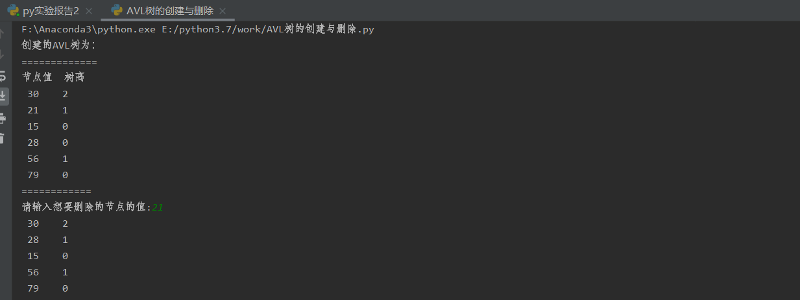
格式要求：各单元格空白行尽量少。
提交要求：电子版，文件命名中将学号和姓名具体化。

